CHAPTER 7: Chemical reactions
Worksheet 7.1

Combustion
Science Quest 9: pages 256–7
Answers

A burning candle
1. The photograph shows a burning candle.
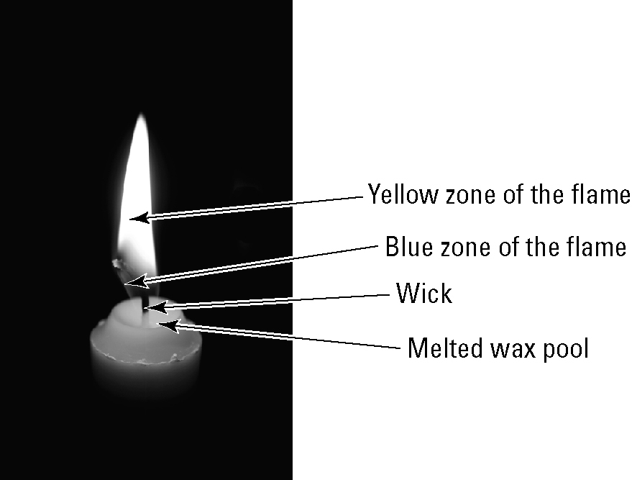
(a) In the blue zone of the flame the wax molecules are burning in oxygen to form carbon dioxide and water vapour. Write a word equation to represent this.
© a40757/Shutterstock
Wax + oxygen → carbon dioxide + water

(b) In the yellow zone of the flame the wax is burning in oxygen to form a mixture of carbon dioxide, carbon monoxide, carbon (soot) and water vapour. Write a word equation to represent this.
Wax + oxygen → carbon + carbon monoxide + carbon dioxide + water

(c) The heat from the combustion melts some of the solid wax and a pool of liquid wax collects at the top of the candle. Explain the purpose of the absorbent, fibrous wick in the combustion process.
The wick absorbs the melted wax, which then moves up the wick towards the flame where it vaporises and combines with the oxygen.

(d) How could you manipulate the collar of a Bunsen burner to achieve a flame similar to that of the candle?
Rotate the collar to almost close the hole. Just allow a little air in.

Modelling combustion
2. The information below shows a way of modelling the combustion of methane (CH₄) based on a word equation. Notice that the same number of carbon, hydrogen and oxygen atoms are on each side of the arrow.
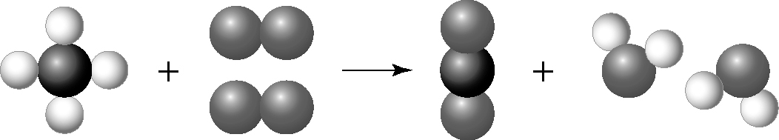
Word equation: methane + oxygen → carbon dioxide + water

The photograph below shows an oxyacetylene welder. In the combustion, acetylene (C₂H₂) burns in oxygen (O₂) to form carbon dioxide and water.
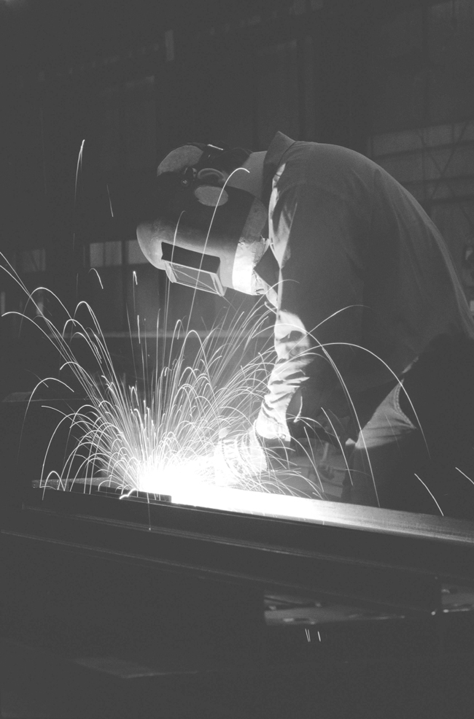
(a) Write a word equation for the combustion of acetylene.
Acetylene + oxygen → carbon dioxide + water
© Photodisc
(b) Using the methane example as a guide, draw a series of models of each molecule in the combustion of acetylene to illustrate your word equation. Ensure that the same number of atoms of each type appear on each side of the arrow.
